P.36

Companies locating in Medi Park will be eligible for transformational finance support.

P.39

Broadmarsh shopping centre redevelop

P.40

develop Energy Park

P.42

the Invest in Nottingham Club

Business Improvement Districts (BIDs)

Trent

Bridge, Nottingham Forest FC, and Notts

County FC

P.51

develop the railway station area into a vibrant city quarter

P.52

two new lines, Destinations include the NG2 business park, the Queen’s Medical Centre and the University of Nottingham.

P.55

Recent deals have added momentum to the Southside Business District, a cluster of corporate commercial offices around the city’s main transport hub in Station Street, the Nottingham railway station and the tram terminus.

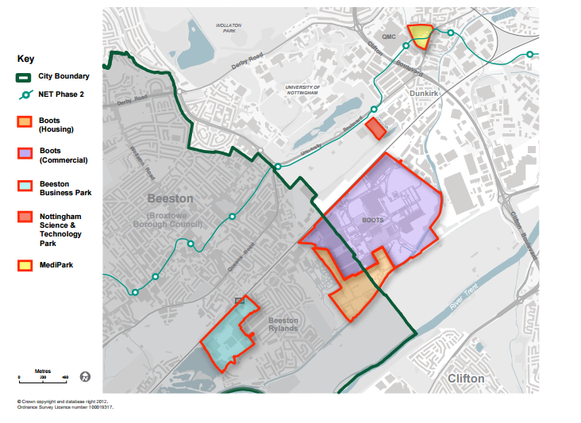

Redevelopment of Boots campus as an Enterprise Zone

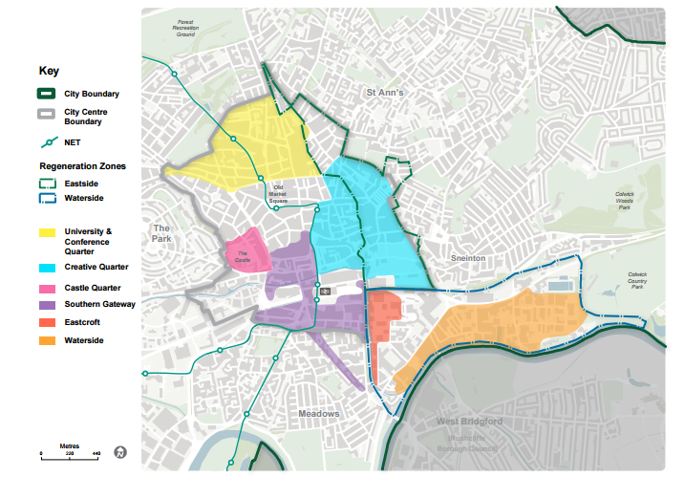

P.56

Project: Southern Gateway

P.57

the Sandfield Village project

Project: Waterside

Project: Eastcroft

P.58

Project: The Creative Quarter

Nottingham Science Park(new tram line)

P.60

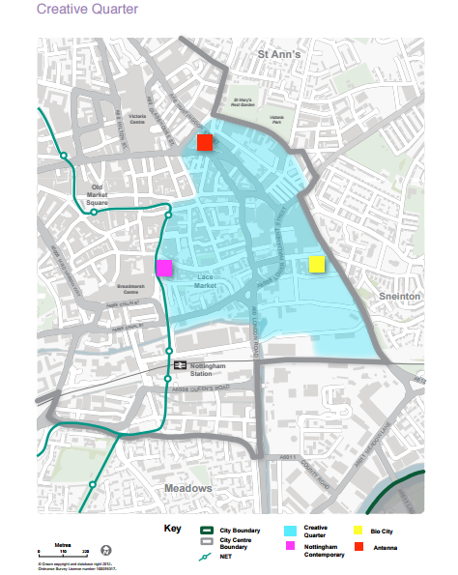

Project: Expansion of Antenna

Project: Expansion of BioCity

P.65

Project: Nottingham CleanTech Centre

Southglade Food Park